4.4 Filter data

Dataflow Gen2
Clicking on the disclosure arrow at the top of a column opens up the filtering options for that column:
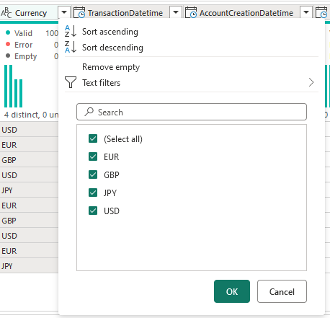

T-SQL Data Warehouse
- Filtering using T-SQL is done using the WHERE clause - there are many variations
-- Filtering using < > <= >= != = AND OR BETWEEN
SELECT customer_id
, customer_name
FROM raw.hubspot_contacts
WHERE customer_id > 50

--DW004_02
SELECT customer_id
, customer_name
FROM raw.hubspot_contacts
WHERE customer_id BETWEEN 10 AND 15
Filtering if in a list:

--DW004_03
SELECT customer_id
, customer_name
, customer_city_id
, customer_email
FROM raw.hubspot_contacts
WHERE customer_id IN (1, 45, 78, 99)
Filtering string columns using the LIKE and the % operator:
SELECT customer_name
FROM raw.hubspot_contacts
WHERE customer_name LIKE 'P%'

